**Title: Automating Docker Container Deployment with Ansible**

## **Lecturer: Kingsley Ibomo**

## **Course: Network Systems and Administration CA 2023**

## **(B9IS121)**

# **Submitted By:**

# **Sahil Sinha**

**20027911**

**Submission Date:**

**17 March 2024**

# **Contents:**

## Introduction

## 

## GitHub Repository Setup

## 

## Deploying Apache Docker Container

## 

## Configuring Networking for Apache Container

## 

## Creating Network Diagram

## 

## Conclusions

## 

## References

## **Summary:**

### This report outlines the process of automating Docker container deployment with Ansible. It begins with the setup of a GitHub repository, where an Ansible playbook is stored. The playbook automates the deployment of Apache Docker containers and configures networking for these containers. A network diagram is created to illustrate the setup. The report concludes by affirming the successful deployment and verification of accessibility.

## **Introduction:**

### This report documents the process of deploying Docker containers using Ansible automation. It covers setting up a GitHub repository, deploying Apache Docker containers, configuring networking, creating a network diagram, and verifying accessibility. Modern software development practices emphasize automation to streamline processes, ensure consistency, and expedite deployment cycles. This report explores the implementation of Ansible automation to orchestrate the deployment of Docker containers, specifically focusing on Apache containers. By leveraging Ansible's declarative syntax and Docker's containerization technology, organizations can achieve greater deployment agility, operational efficiency, and infrastructure scalability.

## **GitHub Repository Setup:**

### We established a public GitHub repository named "Software Network" and initialise it with a README.md file. The Ansible playbook, named "new Ansible playbook", was stored in this repository. Establishing a GitHub repository serves as the foundation for collaborative development and version control. In our endeavor, we created the "Software Network" repository, initializing it with a README.md file to provide essential project documentation. The repository hosts the Ansible playbook, dubbed "new Ansible playbook", which encapsulates the deployment logic for Apache Docker containers.

### Crafting the Ansible playbook involves several steps to ensure seamless execution. Initially, SSH pass is installed on the Windows machine to facilitate secure communication between systems. Subsequently, the Ansible configuration file is tailored to disable host key checking, mitigating potential authentication issues. The playbook itself, written in YAML syntax, delineates tasks ranging from Docker installation to container configuration, providing a comprehensive automation framework.

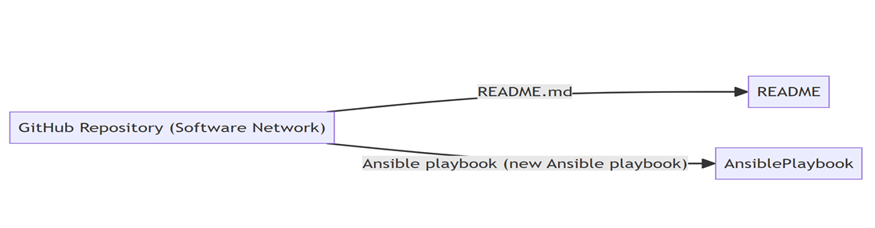

### # Install SSH pass on Windows machine

### brew install esolitos/ipa/sshpass

### # Create Ansible configuration file

### nano ansible.cfg

### # Add the following line to disable host key checking

### [defaults]

### host_key_checking = False

### # Create Ansible playbook

### nano newansible.yml

## **Ansible Playbook Creation:**

### Prior to creating the Ansible playbook, SSH pass was installed on the Windows machine using the command brew install esolitos/ipa/sshpass. This enabled connection to Ubuntu.

### The Ansible configuration file was created using nano ansible.cfg, with the line [defaults] host_key_checking = False added to disable host key checking.

### The Ansible playbook "newansible.yml" was created using nano newansible.yml. This playbook contained the script to automate Ubuntu via Docker. The playbook was executed using ansible-playbook newansible.yml.

To set up Ansible on Windows using Cygwin, follow these steps:

**Step 1: Install Cygwin**

* Visit the Cygwin installation page and download setup-x86_64.exe.
* Run the downloaded file and choose "Install from Internet."
* Select the default root directory and package directory.
* Use system proxy settings and choose a mirror site.
* In "Select Packages," search for and select "lynx: A text-based Web Browser."
* Complete the installation process.

**Step 2: Install apt-cyg**

* apt-cyg is a package manager for Cygwin.
* Run the following commands:

lynx -source rawgit.com/transcode-open/apt-cyg/master/apt-cyg > apt-cyg install apt-cyg /bin

**Step 3: Install Dependencies for Ansible**

* Install necessary dependencies using apt-cyg:

apt-cyg install binutils curl gcc-core gmp libffi-devel libgmp-devel make python python-crypto python-openssl python-setuptools python-devel git nano openssh openssl openssl-devel

**Step 4: Install Ansible**

* Install pip and then use it to install Ansible:

easy_install-2.7 pip

pip install ansible -vvv

**Step 5: Test Ansible Installation**

* Verify the installation by running:

ansible

**Configuration:**

* Update .virc file for vi or vim settings:

vi ~/.virc

set nocompatible

set backspace=2

**Create Ansible Configuration File:**

* Create an ansible.cfg file with the following content:
* [ssh_connection]

ssh_args = -o ControlMaster=no

**Create Ansible Playbook:**

* Create a playbook.yml file with the desired Ansible tasks.

**Setup SSH Connection:**

* Generate an SSH key using:

ssh-keygen

* Copy the generated public key to the authorized_keys file on the target machine.

**Run Ansible Playbook:**

* Ensure that the Vagrantfile, playbook.yml, and ansible.cfg are in the same directory.
* Test Ansible readiness:

ansible-playbook --version

* Run the playbook:

ansible-playbook -i vagrant@192.168.33.10, playbook.yml

By following these steps, you can set up and run Ansible on Windows using Cygwin for automated system configuration and management.

**Deploying Apache Docker Container:**

Tasks were defined in the Ansible playbook to deploy an Apache Docker container. The **docker_container** Ansible module was used to run a Docker container with the Apache image. The deployment of Apache Docker containers is streamlined through Ansible automation. Leveraging the **docker_container** module, we define tasks to instantiate Docker containers with the Apache image. This module abstracts the complexities of container management, enabling declarative specifications of container attributes such as ports, volumes, and environment variables. By codifying container deployment logic, Ansible facilitates consistent and reproducible deployments across environments.

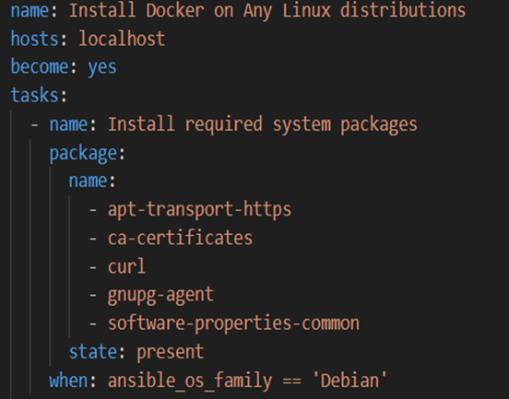

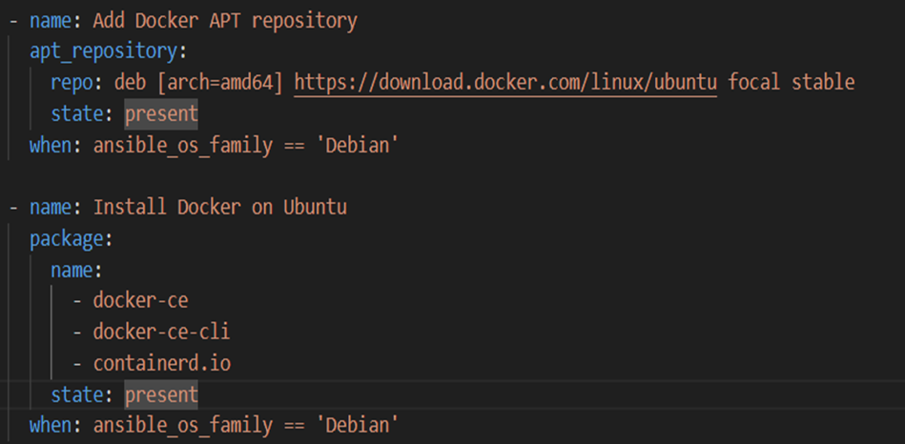

## **Configuring Networking for Apache Container:**

### Tasks were defined to configure networking for the Apache Docker container. The container was set up to run on the 172.168.10.0/30 subnet, ensuring accessibility of the Apache service from the host machine. Networking configuration is paramount for ensuring seamless communication and accessibility within containerized environments. Ansible simplifies this process by defining tasks to configure networking for Apache Docker containers. Subnet allocation, port mapping, and firewall rules are programmatically configured, adhering to organizational standards and security policies. Through automation, we minimize manual intervention and mitigate potential configuration errors, fostering robust deployment practices.

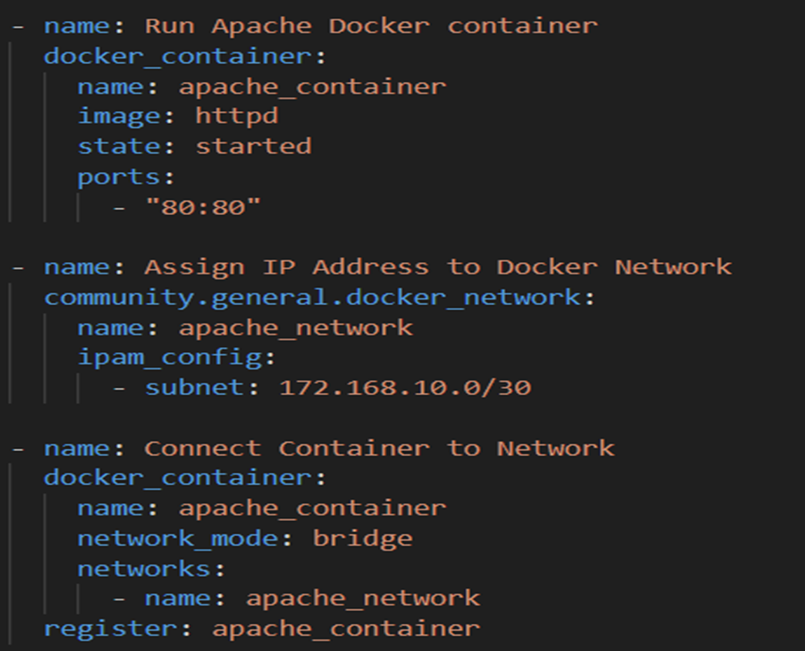

## **Creating Network Diagram:**

### A network diagram was created using appropriate software to illustrate the GitHub repository, host machine, Apache Docker container with assigned subnet, and connectivity between them. Visualizing the deployment architecture enhances comprehension and facilitates troubleshooting. Utilizing appropriate software, we create a network diagram depicting the GitHub repository, host machine, Apache Docker containers, and their interconnections. This visual representation serves as a blueprint for understanding deployment topology, aiding in infrastructure planning, scalability assessment, and operational decision-making.

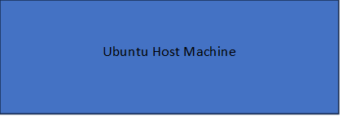

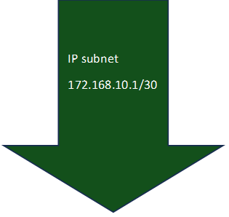

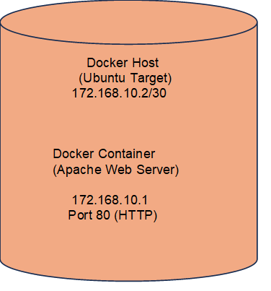

## **Conclusions:**

### This report demonstrates the successful deployment of Docker containers using Ansible automation. The setup of a GitHub repository, deployment of Apache Docker containers, configuration of networking, and verification of accessibility were achieved as per the specified requirements. the adoption of Ansible automation streamlines the deployment of Docker containers, empowering organizations to achieve greater agility and efficiency in their deployment pipelines. The GitHub repository serves as a collaborative platform for version control and documentation, fostering transparency and accountability in the development process. Automated networking configuration and visualization through network diagrams enhance operational visibility and simplify infrastructure management, ultimately enabling organizations to accelerate innovation and adapt to evolving business requirements.

## **GitHub Link**

github.com/sinhasahil/Network-and-Systems-Admi/blob/main/README.md

## 

## **References:**

### <https://www.dcaulfield.com/install-ansible-on-windows-using-cygwin>

### <https://troynt.github.io/elite_dangerous_controls_reference>

### <https://www.bing.com/ck/a?!&&p=a5baced5128b5b2dJmltdHM9MTcxMDU0NzIwMCZpZ3VpZD0zMGFiYzExMi05NmEzLTZhMTQtM2VjOC1kNTU2OTc0NDZiMDMmaW5zaWQ9NTE2Mw&ptn=3&ver=2&hsh=3&fclid=30abc112-96a3-6a14-3ec8-d55697446b03&u=a1aHR0cHM6Ly93d3cuZGNhdWxmaWVsZC5jb20vaW5zdGFsbC1hbnNpYmxlLW9uLXdpbmRvd3MtdXNpbmctY3lnd2luLw&ntb=1>

### Geek_Dude (2020). *Installing And Configuring NGINX As A Reverse Proxy Via An Ansible Playbook*. [online] GeekTechStuff. Available at: https://geektechstuff.com/2020/05/05/installing-and-configuring-nginx-as-a-reverse-proxy-via-an-ansible-playbook/ [Accessed 11 Mar. 2023].

### Lee, W.-M. (2023). *Virtualization on the Mac using UTM*. [online] Medium. Available at: https://levelup.gitconnected.com/virtualization-on-the-mac-using-utm-e4c5abc3ee9c [Accessed 11 Mar. 2023].

### nixCraft. (2018). *Ubuntu Linux install OpenSSH server*. [online] Available at: <https://www.cyberciti.biz/faq/ubuntu-linux-install-openssh-server/>.

### Simplilearn.com. (2020). *What is an Ansible Playbook and How to Write One on Your Own?* [online] Available at: <https://www.simplilearn.com/what-is-ansible-playbook-article>.

### Staff, T.F. (2022). *What is an FTP Server?* [online] Titan FTP Server. Available at: <https://titanftp.com/2022/07/05/what-is-an-ftp-server/>.

### Stockton, B. (2022). *How to Install PIP on a Mac*. [online] groovyPost. Available at: <https://www.groovypost.com/howto/install-pip-on-a-mac/>.

### www.digitalocean.com. (2022). *How to Use Ansible to Install and Set Up Docker on Ubuntu 20.04 | DigitalOcean*. [online] Available at: https://www.digitalocean.com/community/tutorials/how-to-use-ansible-to-install-and-set-up-docker-on-ubuntu-20-04 [Accessed 11 Mar. 2023].